|  |  |
| --- | --- |
| **Ex. No: 7** | **Routing Implementation using ExpressJS** |
| **28.09.2023** |

**Aim:**ToImplement the routing feature(s) using the ExpressJS.

**Algorithm:**

1. Include the required header files thread creation and sleep() function.
2. Write a function that executes as a thread when it is called. (sleep – print - return)
3. thread_id is declared to identify the thread in the system, we call pthread_create() function to create a thread.
4. The pthread_join() function for threads is the equivalent of wait() for processes. A call to pthread_join blocks the calling thread until the thread with identifier equal to the first argument terminates.

**Program:**

const express = require('express');

const app = express();

const port = 3000;

app.use(express.json());

let notes = [];

app.use(express.static('public'));

app.use((req, res, next) => {

console.log(`Received ${req.method} request at

${req.url}`);

next();

});

app.get('/api/notes', (req, res) => {

res.json(notes);

});

app.post('/api/notes', (req, res) => {

const { title, content } = req.body;

const newNote = { id: notes.length + 1, title, content };

notes.push(newNote);

console.log(`Added a new note: "${title}"`);

res.status(201).json(newNote);

});

app.delete('/api/notes/:id', (req, res) => {

const idToDelete = parseInt(req.params.id);

notes = notes.filter(note => note.id !== idToDelete);

console.log(`Deleted note with ID: ${idToDelete}`);

res.sendStatus(204);

});

app.listen(port, () => {

console.log(`Server is running on port ${port}`);

});

<!DOCTYPE html>

<html>

<head>

<title>Note Taking App</title>

</head>

<body>

<h1>Notes</h1>

<form id="noteForm">

<input type="text" id="noteTitle"

placeholder="Title" required>

<textarea id="noteContent" placeholder="Content"

required></textarea>

<button type="submit">Add Note</button>

</form>

<ul id="noteList"></ul>

<script>

const noteForm =

document.getElementById('noteForm');

const noteTitle =

document.getElementById('noteTitle');

const noteContent =

document.getElementById('noteContent');

const noteList =

document.getElementById('noteList');

noteForm.addEventListener('submit', async (e) => {

e.preventDefault();

const title = noteTitle.value;

const content = noteContent.value;

if (!title || !content) return;

try {

const response = await fetch('/api/notes',

{

method: 'POST',

headers: {

'Content-Type':

'application/json',

},

body: JSON.stringify({ title, content

}),

});

const newNote = await response.json();

noteTitle.value = '';

noteContent.value = '';

displayNote(newNote);

} catch (error) {

console.error('Error adding note:',

error);

}

});

async function fetchNotes() {

try {

const response = await

fetch('/api/notes');

const notes = await response.json();

notes.forEach(displayNote);

} catch (error) {

console.error('Error fetching notes:',

error);

}

}

function displayNote(note) {

const listItem = document.createElement('li');

listItem.innerHTML = `<strong>${note.title}

</strong>: ${note.content} <button>Delete</button>`;

const deleteButton =

listItem.querySelector('button');

deleteButton.addEventListener('click', async

() => {

try {

await fetch(`/api/notes/${note.id}`, {

method: 'DELETE' });

listItem.remove();

} catch (error) {

console.error('Error deleting note:',

error);

}

});

noteList.appendChild(listItem);

}

// Initial fetch

fetchNotes();

</script>

</body>

</html>

**Output:**

Github Link: https://github.com/AsHtrich/Web_tech2023

1. Initial webpage when the server is started.

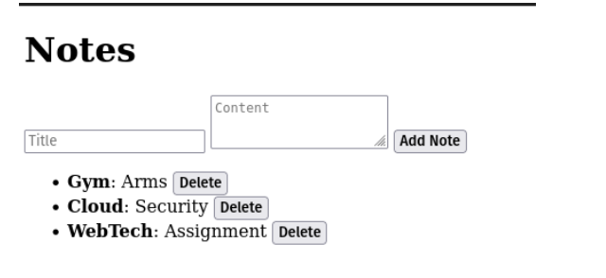

1. All the content for that session can be assesed in the /api/notes route in json formate

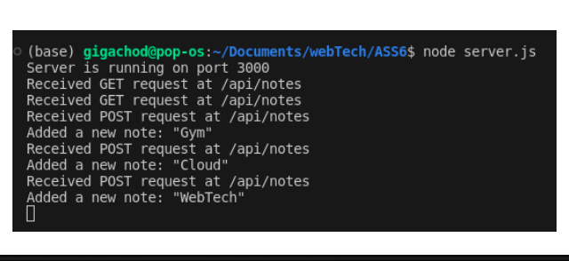

**Result:**

Therefore, we've successfully implemented a basic routing implementation using Express JS